Want to Practice Regenerative Agriculture while Having Fun on the Farm?
…… ExerFarm and Deep Roots Hub are looking for volunteers!

More and more studies are showing that gardening can reduce stress, anger, fatigue, depression, and anxiety… all of which can help increase both a person’s life span and health. Regenerative agriculture provides huge benefits both for health and for combating climate change.

In addition to preparing the soil and planting, weeding, and harvesting the bounty, volunteers will have a unique opportunity to learn from other volunteers, local farmers and local businesses around the connection between regenerative agriculture, sustainable food systems, and health.
Local farmers are sharing their knowledge and reference materials around regenerative agriculture techniques that we can practice on the farm such as no-tilling mulch approaches, hügelkultur, bio-char, inoculation with fungi from leaf compost, indigenous growing methods, and much, much more. Many of these techniques could be applied at WCSS, should there be an appetite for gardening on the school grounds. See reference for engaging youth in food learning: https://seeds.ca/schoolfoodgardens/; Local businesses are engaged to process and distribute the vegetables right here in Carp. Students will also have a ground floor opportunity to explore different marketing options for the vegetable products.

In 2021, we grew a small plot of very colourful indigenous corn that the local Mill and Bakery processed with great results. This year, we are excited to expand the project to involve more farmers and grow large amounts of corn. This will assist the Deep Roots Food Hub in its mandate to create an autonomous self-sufficient local food system(s) in West Carleton, while providing human nutrition in the form of vegetables for local processing, distribution and consumption minimizing distribution impact, food wastage and costs.

The plan below is dynamic and will evolve as we learn more information. Volunteers are needed as early as the end of April to help prepare the soil. Planting will begin toward the end of May.

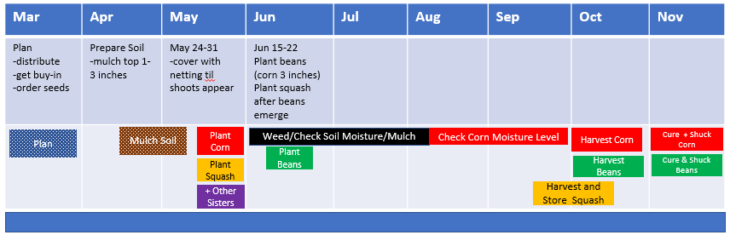
Any time that volunteers can donate would be most welcome!

About Exerfarm and the Deep Roots Hub…
In 2018, Dr. Barry Bruce, a semi-retired family physician in Carp, started ExerFarm as a way of introducing healthy nutrition and a free form of exercise. As a family physician, he is interested in disease prevention, healthy lifestyles, and climate change. Many factors affect the health of individuals and communities. People’s health is determined by their circumstances and environment but to a large extent, the health care system has less of an impact on health than does our environment and our relationships with friends and family. He saw that he could make a difference and teach healthy behaviors through manual vegetable farming, resulting in increased physical fitness with a purpose, better nutrition and a positive contribution to climate change.
Local farmers have generously donated land for ExerFarm’s use on Donald B Munro Dr. in Carp (about 1/4 acre) and off Dwyer Hill Road (about 2/3 acre). Some of the crop goes to volunteers, based on effort spent, some goes toward covering expenses and some goes to local charities such as food banks.
The "Deep Roots Food Hub" has as its mandate to address food insecurity in West Carleton, climate change and human nutrition- these being closely linked. The root cellar is an off-grid, above ground, semi-autonomous hi-tech structure with now 2 seasons of successfully storing root crops from the ExerFarm and Community Supported Agriculture products over the winter. Most of ExerFarm's root crops will end up being stored in the root cellar over winter at a cozy 6 degrees Celsius. Dr. Bruce was chief designer and builder of the resulting root cellar (with lots of volunteer help) see http://www.deeprootsfoodhub.ca/.

